MARIE LUNDMARK TROPHY
Planned Program Content
This foRm must bE RETURNED BY DECEMBER 22, 2021
Please fill in with type or write in capital letters! | FORM 08
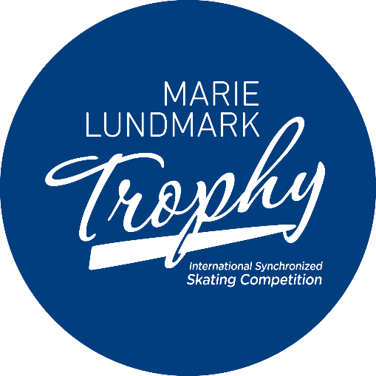

ISU Member:
Category:
Name of the team:
Theme of the music:

ELEMENTS IN ORDER OF SKATING – terminology according to ISU Communications

 | Time | Free Program Elements
1
2
3
4
5
6
7
8
9
10
11
12

Date, Signature
Please send to the Organizing Committee via weblink.

